Competitive Programming
3 rd Assignment
Week - 7.14 Wednesday
Hallticket : 2303A52382

Maximum Flow in a Transportation Network
Problem Statement
A logistics company transports goods from a warehouse (source) to
retail stores
(sink).
Each road has a maximum carrying capacity.
Find the maximum number of goods that can be transported per day.
Sample Input
5 7
0 1 8
0 2 10
1 3 5
2 3 7
1 4 3
3 4 10
2 4 6
0 4
Expected Output
Maximum Flow = 13
# Python code :
from collections import deque
def bfs(capacity, flow, source, sink, parent):
visited = [False] * len(capacity)
queue = deque([source]) visited[source] = True
while queue:
u = queue.popleft()
for v in range(len(capacity)):
if not visited[v] and capacity[u][v] - flow[u][v] > 0:
parent[v] = u
visited[v] = True
queue.append(v)
if v == sink:
return True
return False
def max_flow(V, capacity, source, sink):
flow = [[0]*V for _ in range(V)]
parent = [-1]*V
max_flow_value = 0
while bfs(capacity, flow, source, sink, parent):
path_flow = float('inf')
s = sink
while s != source:
path_flow = min(path_flow,
capacity[parent[s]][s] - flow[parent[s]][s])
s = parent[s]
v = sink
while v != source:
u = parent[v]
flow[u][v] += path_flow
flow[v][u] -= path_flow
v = parent[v]
max_flow_value += path_flow
return max_flow_value
V, E = map(int, input().split())
capacity = [[0]*V for _ in range(V)]
for _ in range(E):
u, v, c = map(int, input().split())
capacity[u][v] = c
source, sink = map(int, input().split())
print("Maximum Flow =", max_flow(V, capacity, source, sink))
Output :
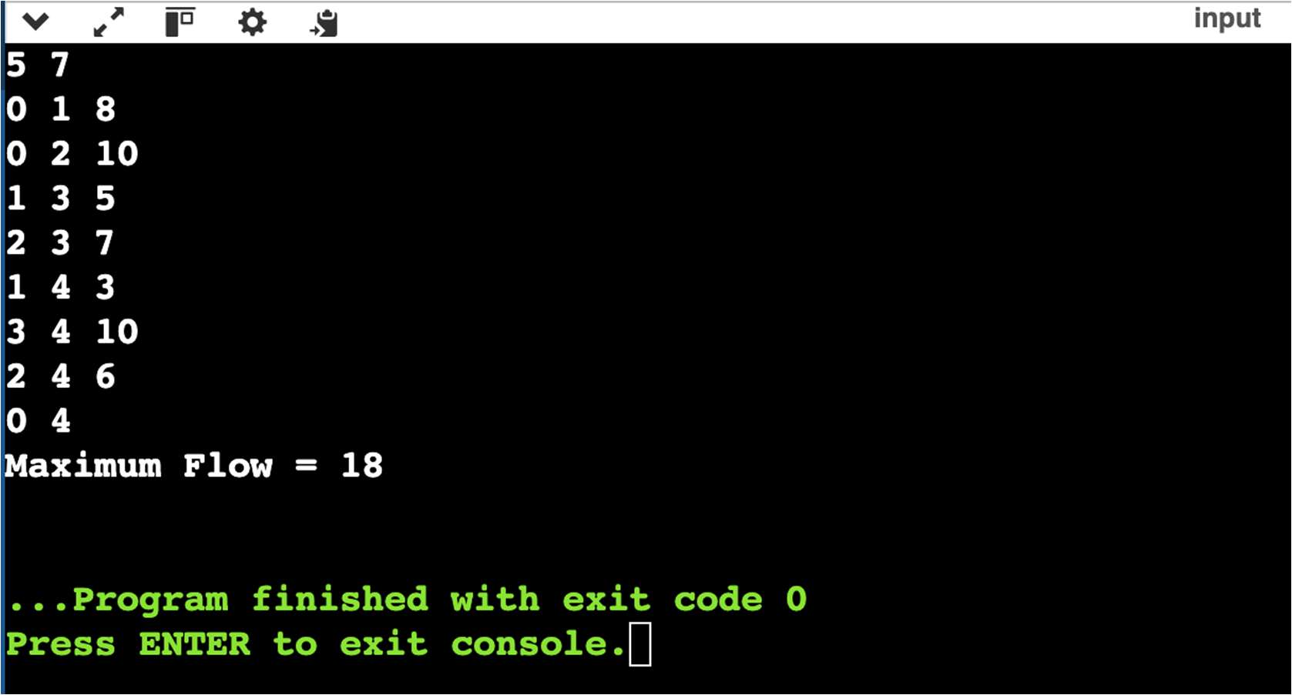
#C Code:
#include <stdio.h>
#include <string.h>
#include <limits.h>
#define MAX 100
int capacity[MAX][MAX], flow[MAX][MAX], parent[MAX];
int V;
int bfs(int source, int sink) {
int visited[MAX] = {0};
int queue[MAX], front = 0, rear = 0;
queue[rear++] = source;
visited[source] = 1;
parent[source] = -1;
while (front < rear) {
int u = queue[front++];
for (int v = 0; v < V; v++) {
if (!visited[v] && capacity[u][v] - flow[u][v] > 0) {
queue[rear++] = v;
parent[v] = u;
visited[v] = 1;
if (v == sink)
return 1;
}
}
}}
int maxFlow(int source, int sink) {
int max_flow = 0;
while (bfs(source, sink)) {
int path_flow = INT_MAX;
for (int v = sink; v != source; v = parent[v]) {
int u = parent[v];
int residual = capacity[u][v] - flow[u][v];
if (residual < path_flow)
path_flow = residual;
}
for (int v = sink; v != source; v = parent[v]) {
int u = parent[v];
flow[u][v] += path_flow;
flow[v][u] -= path_flow;
}
max_flow += path_flow;
}
return max_flow;
}
int main() {
int E;
scanf("%d %d", &V, &E);
memset(capacity, 0, sizeof(capacity));
memset(flow, 0, sizeof(flow));
for (int i = 0; i < E; i++) {
int u, v, c;
scanf("%d %d %d", &u, &v, &c);
capacity[u][v] = c;
}
int source, sink;
scanf("%d %d", &source, &sink);
printf("Maximum Flow = %d\n", maxFlow(source, sink));
}
Output :
